BENJAMIN BULBS

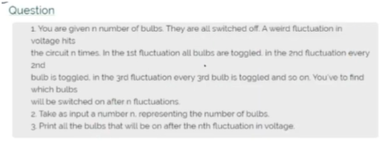

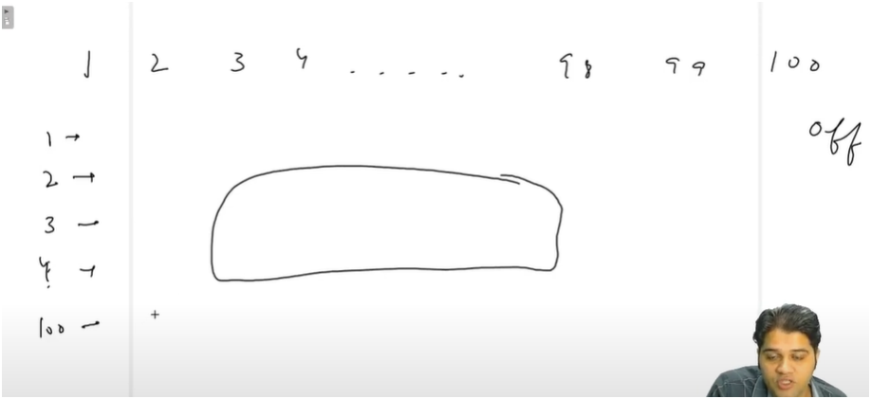

THERE ARE N BULBS A SMALL FLUCTUATION APPEARS IN THE CIRCUIT WHICH RESULTS THE BULB TO TOGGLE (ON AND OFF). WE NEED TO DETERMINE WHICH BULBS REMAIN ON TILL LAST

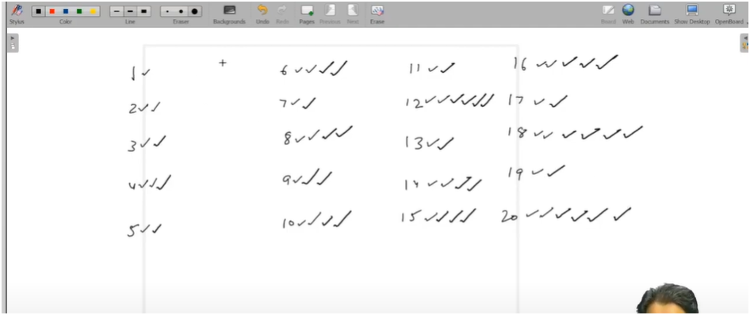

THERE ARE N BULBS AND THERE ARE N FLUCTUATIONS

INITIALLY ALL BULBS ARE OFF

FOR 1ST VOLTAGE ALL BULBS GET ON

FOR 2ND VOLTAGE ALL MULTIPLES OF 2 BULBS GET TOGGLE

FOR 3RD VOLTAGE ALL MULTIPLES OF 3 BULBS GET TOGGLE

AND SO ON

TOGLES(ON / OFF) OF BULBS MAINLY DEPEND UPON MULTIPLES OF FLUCTUATION

**IF U SEE PROPERLY ODDTICKS BULB ARE ON AND EVEN TICKS BULB ARE OFF**

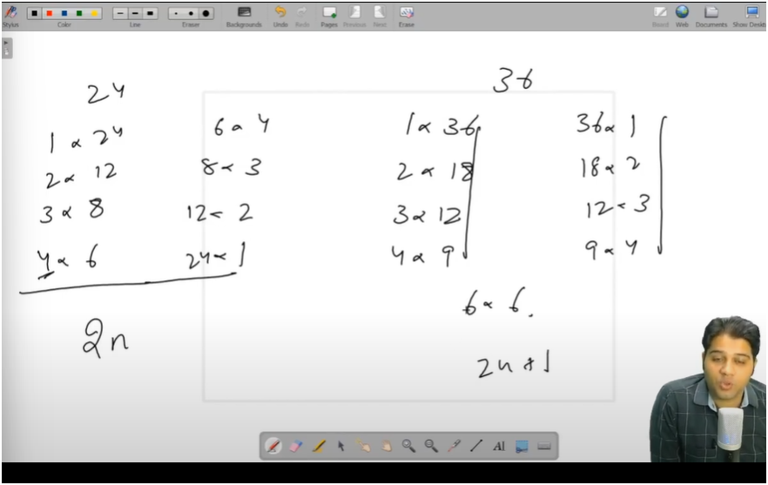

ALL PERFECT SQR HAVE 2N + 1 FACTORS

ALL NON PERFECT SQR HAVE 2N FACTORS

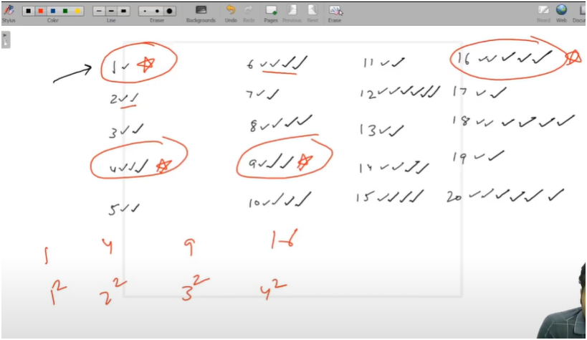

**AFTER N TOGGLING WE ARE ABLE TO SEE ALL PERFECT SQR BULBS ARE ON**